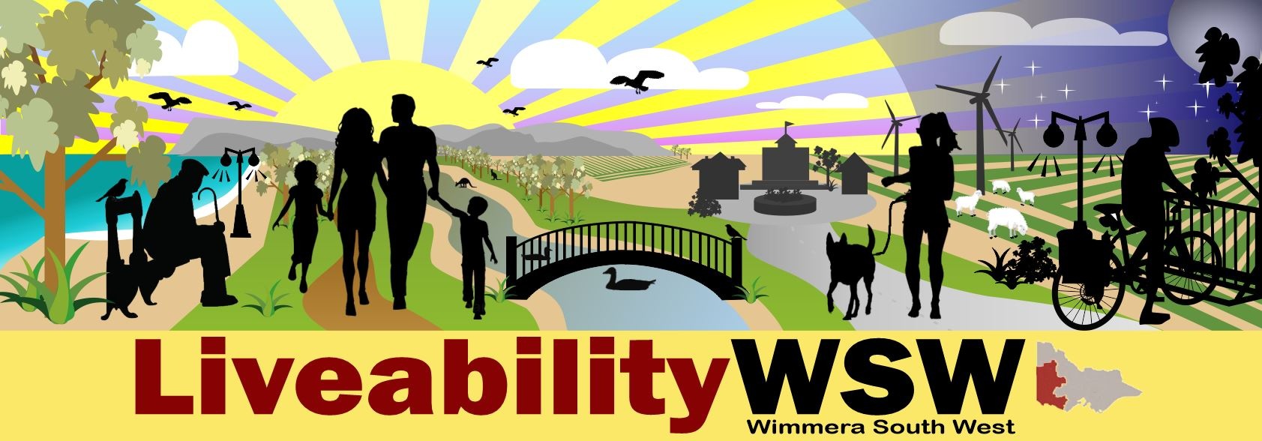Liveability Wimmera South West- Taking the Liveability Framework Concept to a Wimmera Southern Mallee Forum of Wimmera Organisation and Community Leaders.

Background:
Health and wellbeing is linked to social, environment and economical factors, that in health, we know as the social determinants of health- (the conditions in which people are born, grow, work, recreate, live, and age, and the wider set of forces and systems which shape the conditions of daily life). These include education, employment and income, food security, housing and basic utilities for modern life, access to health and social services, social inclusion, and aspects of the built and natural environments which influence our opportunities and our behaviours. These and other similar factors, are also what are generally considered factors of a ‘liveable’ community.
“Liveability” is a broader, more widely used term, that appears as a goal or interest point in many regional plans and strategies, including in Wimmera and South West Regions. Community liveability influences matters of regional/community growth and development; and population (including skilled staff) attraction, retention, and demographics, which through a looping chain of various factors, ultimately influences health and wellbeing of our populations.
Four Primary Care Partnerships of the Wimmera South West area, and with the Department of Families, Fairness and Housing (formerly the Department of Health and Human Services) to lead the development of a Liveability Framework. Ultimately the goal of the framework is support everyone, from every area of work, focus, and expertise, to work together and from the same page, towards the shared goal of community liveability. The framework hopes to encourage ‘out of the box’ thinking in terms of new non-traditional partnerships, and to support balanced and holistic planning and outcomes for community projects. The framework will be supported by comparable data across our rural and regional area, to help inform where change is needed.
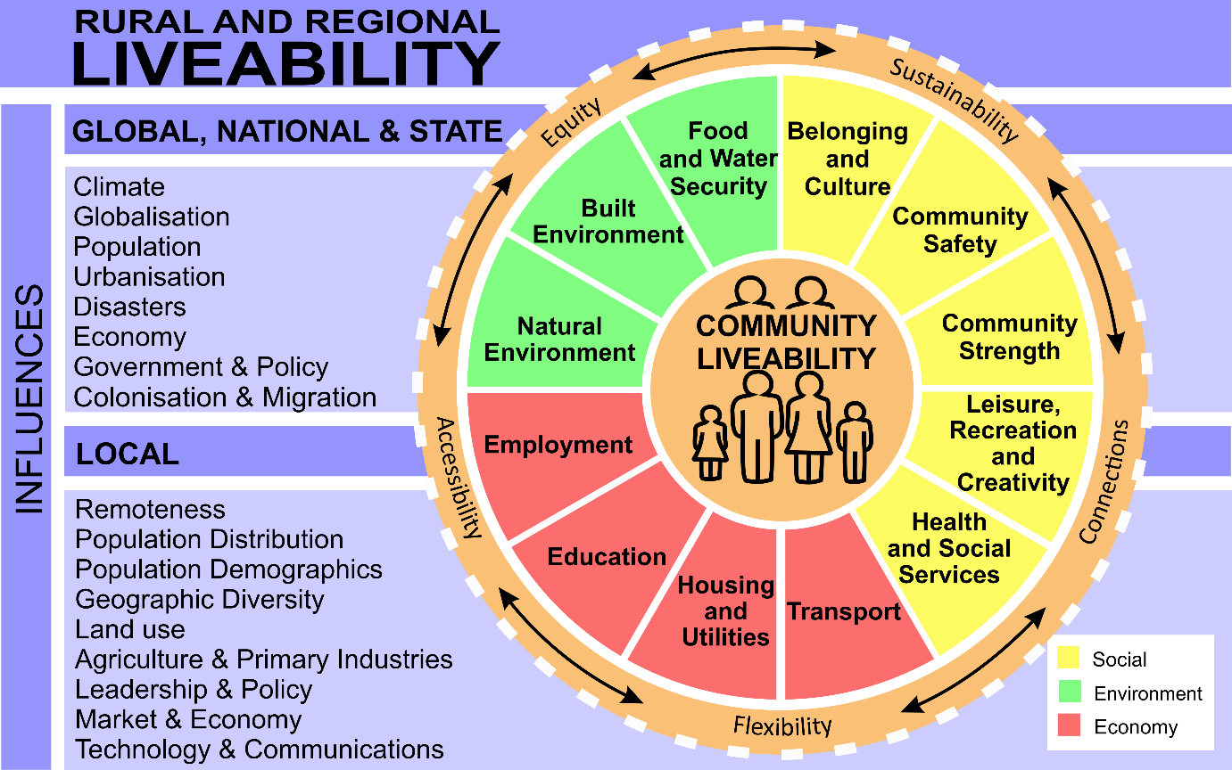

Leadership group partners:
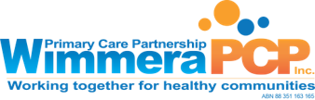

Method:
A draft of the Liveability Framework, including visual representation, was developed by the leadership group, as above. In its first draft form, this was taken to consultation forum with Great South Coast stakeholders, by South West PCP, Southern Grampians Glenelg PCP and DFFH. From this, feedback on the strengths and weaknesses- for example, what factors were missing, and clarity of language- adjustments to the framework were informed. A second draft was introduced at the Wimmera Southern Mallee forum.
Wimmera PCP joined with Wimmera Development Association and Grampians Pyrenees Primary Care Partnership to invite leaders from key Wimmera organisations to the first Wimmera Southern Mallee forum, to provide input and practice application to local matters and projects.

Outcomes:
- 75% and 22% of participants who responded, said yes and somewhat yes respectively, they could see the usefulness of a liveability framework.
- Anonymous feedback of the strengths and weaknesses, and the specifics on the components of the framework were captured, and will be used to inform next steps.

Next steps:
- The Wimmera Liveability Leadership group will be in touch with participants of the Wimmera forum with updates, to seek interest in further participation. With the support of our Wimmera organisation leaders, we intend on holding another forum in the next few months, open to a broader range of stakeholders.

