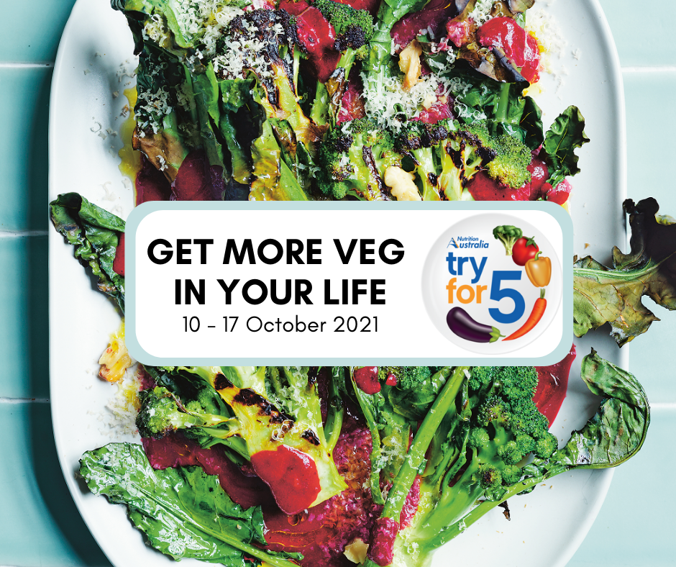

Sarah Green

Acting Prevention Manager

sarahg@southcoastpcp.org.au

0409 798 861

Try for 5

Campaign Toolkit

10 – 17 October 2021

- Campaign Background

Try for 5 is collaboration between Nutrition Australia, vegetable growers and other health-focused organisations to inspire Australians to eat more vegetables. The 2021 campaign theme is ‘Get more veg in your life’.

- Key Messages
- Eat for health: Diets rich in fruit and vegetables have been shown to protect against high blood pressure, obesity, heart disease, stroke, type 2 diabetes and some cancers.
- Eat for mood: Veggies are also good for our mood. What we eat plays a huge role in how we feel physically, and mentally. When we eat better, we feel better.
- The COVID opportunity: There’s no better time to make a change to how we eat. More vegetables, more mealtimes together and more opportunities to connect with family and friends.
- Only 7.5% of Australian adults eat enough vegetables: Increasing the amount of vegetables we eat is everyone’s job, not just so we can feel and live well right now, but so we can look after the generations to come after us.
- Get more veg in your life. Try for 5 and feel the difference.

- Campaign Resources
Within this kit you will find:
- Social media content
- Staff newsletter insert

Social media content
Social media posts have been developed for Try for 5. Below is a table of the content and images for posting on your organisation social media.

Jpg versions of the images are attached to this email. These can be scheduled on your social media platform, so you can simply set and forget.

If you need any support please do not hesitate to contact us.

Date | Post Content | Image (sample not for use)
Monday  11 Oct | Join us as we celebrate vegetables and the important role they can play in our health and wellbeing during Try for 5, 10 - 17 October.  Vegetables are not just good for our bodies, they are also good for our mood! What we eat plays a huge role in how we feel - simply put, when we eat better, we feel better.  Find out how you can fuel your body and brighten your mood by exploring www.tryfor5.org.au  #Tryfor5 #GetMoreVeg | 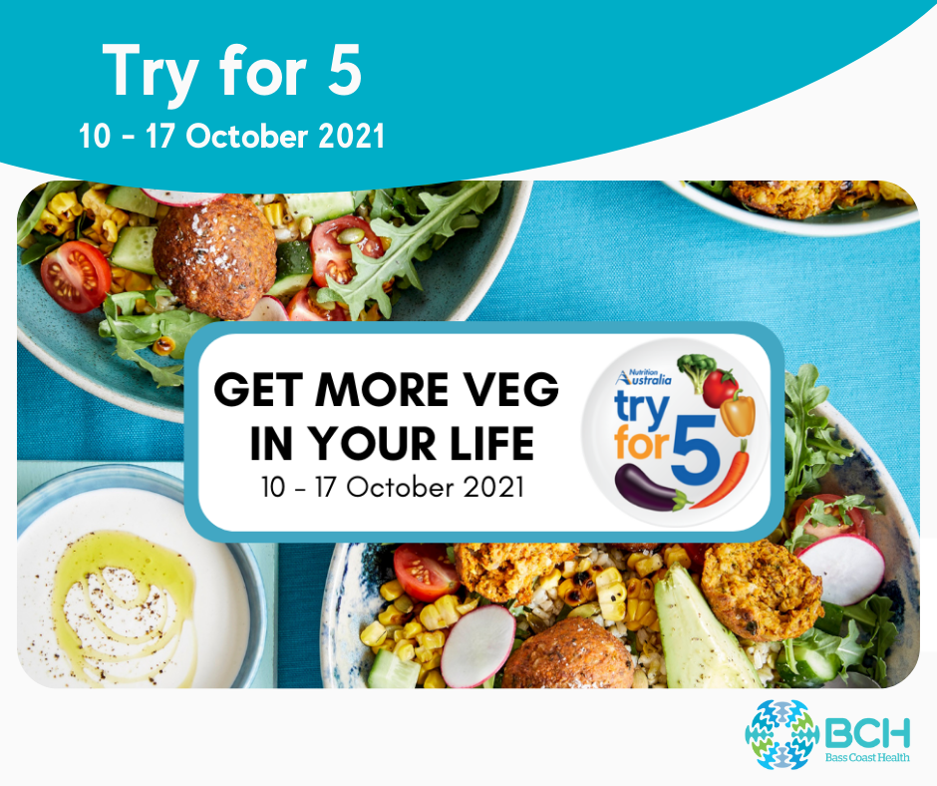
Thursday 14 Oct | Our dietitians are challenging you to eat 5 serves of veg a day!  A tip from our dietitian Anita – “There are plenty of ways you can add veggies to the meals and snacks you already love. Grate a carrot or zucchini into mince dishes such as a pasta sauce, add capsicum or mushrooms to an omelette or try savoury muffins for a yummy snack on the go”.  Visit www.tryfor5.org.au to view over 100 new vegetables recipes and videos, as well as tips, hacks and downloadable resources for increasing your veggie intake.  #Tryfor5 #GetMoreVeg | 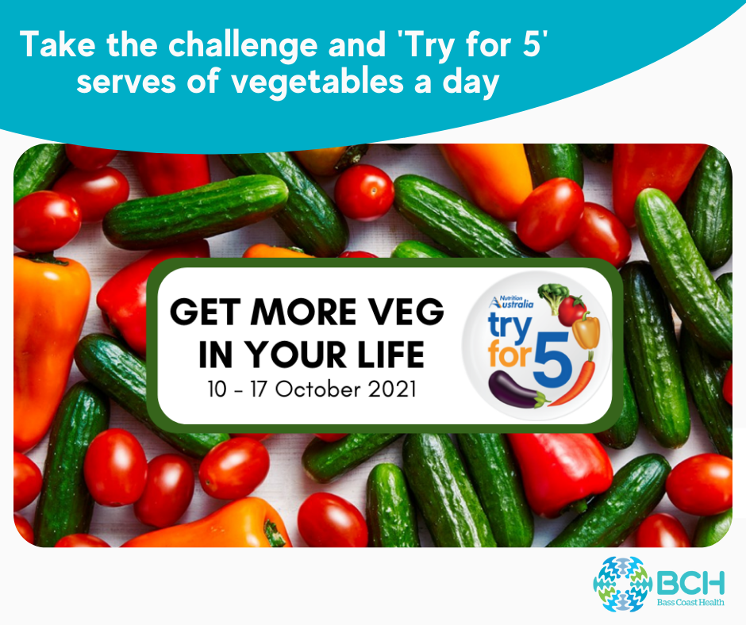

Staff newsletter insert

Eat on the bright side during ‘Try for 5’ week
Join us as we celebrate vegetables and the important role they can play in our health and wellbeing during ‘Try for 5’ week, 10 - 17 October.
Vegetables are not just good for our bodies, they are also good for our mood! What we eat plays a huge role in how we feel - simply put, when we eat better, we feel better.
Learn how your mood can be improved with vegetables using The Good Mood Food’s interactive tool www.thegoodmoodfood.com.au
You can also discover how you can fuel your body and brighten your mood with vegetables by exploring www.tryfor5.org.au

