**End of Year Report 2021**

**Chair Report**

It has been a big year and an immensely challenging one at that! l would like to acknowledge the support of all the members in continuing to make this partnership a successful one. Our members come to our meetings ready to share, learn, debate and support each other. We are very lucky to have such passion, knowledge and skills in our sub-region.

We kicked off 2021 with agreement to work with a stronger focus on intersectionality, inclusion and diversity, directing a partnership name change and new vision.

In July, Rebecca Scott was seconded to Bass Coast Health and I took over the chairing responsibilities.

The COVID-19 pandemic continued and the Partnership remained connected via zoom, continuing our prevention work and supporting the community the best we could.

Partners participated, hosted and conducted training across the sub-region throughout the year.

Our largest combined activity for the year was the 16 Days of Activism campaign. Our members were involved in delivering the Let’s Chat Gippsland campaign, led by Gippsland Women’s Health through community events, social media campaigns, podcasts, visual presence and local print media.

2021 also saw the departure of Change for Sam from the Partnership, as it transitioned to a registered charity.

Looking forward into 2022, we will review and update our Strategic Plan. We will continue to strengthen and align our work with the [2nd Edition Change the Story](https://www.ourwatch.org.au/resource/change-the-story-summary), to expand our focus on intersectionality we will reach out to our diverse communities for representation on the partnership and establishment of relevant activities.

Revised department policy direction will bring about new opportunities and challenges for the partnership, but the strong foundation established in the group will ensure its longevity.

Also looking forward to the prospect of some face-to-face meetings in 2022!

Rachel Sands, Health Promotion Officer, South Coast Primary & Community Partnership

**Partnership Members**

South Coast Primary & Community Partnership (Chair)

South Gippsland Shire Council

Bass Coast Health (*represented by SCPCP Prevention Team)

Bass Coast Shire Council

Gippsland Southern Health Service (*represented by SCPCP Prevention Team)

Gippsland Centre Against Sexual Assault - GCASA

Gippsland Women's Health - GWH

Milpara Community House

Respectful Relationships DET

Salvation Army

South Gippsland Hospital (*represented by SCPCP Prevention Team)

Phillip Island Nature Parks - PINP

Westernport Water

Gippsland Legal Assistance Forum which is comprised of Victoria Legal Aid, Gippsland Community Legal Service, Victorian Aboriginal Legal Service and Djirra

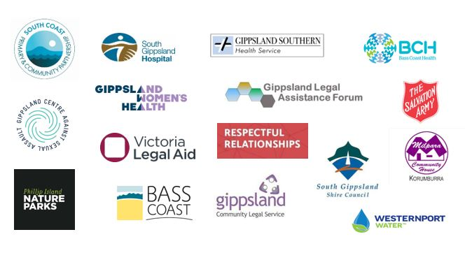

**Achievements in 2021**

**Name and Vision updates**

Early in 2021, discussion commenced and agreement reached on the need for our name and vision to be more inclusive, relevant to the purpose of each agency and in line with [VicHealth’s new Gender Equity messaging](https://www.vichealth.vic.gov.au/-/media/ResourceCentre/PublicationsandResources/Mental-health/Framing-gender-equality---Message-guide.pdf?la=en&hash=AF111835871BFA3092C1F9DD98B3C8AA0E493295). We became the Partnership to Prevent Family Violence in South Gippsland and Bass Coast; an inclusive, equitable and respectful community where everyone is free from violence.

**Training**

Members of the Partnership participated, hosted and conducted training across the sub-region during in 2021, including:

* Healthier Masculinities Training for partners, facilitated by Paul Zappa from the Jesuit Social Services
* Gender Equality Messaging Workshop (values-based messaging) organised by GWH and facilitated by Mark Chenery from Common Cause.
* Unpacking Resistance and Backlash Training delivered by DV Vic/DVRCV to support partners to respond to any resistance and backlash during the 16 Days campaign.

**Learning from each other**

In June, some of our members presented to the Partnership to continue to strengthen local referral pathways and professional learning. We are grateful to our partners for sharing their expertise with us.

Kris Atkinson from Salvation Army - Unpacking the Response Process

Penelope Swailes from represented the Gippsland Legal Assistance Forum which is comprised of Victoria Legal Aid, Gippsland Community Legal Service, Victorian Aboriginal Legal Service and Djirra - Legal Process of an Intervention Order

Bianca Pezzuto from GCASA - Intake Process

Ginger Ekselman from GCASA - Sexual Lives and Respectful Relationships

**International Women’s Day**

Many of our Partners delivered events and social media campaigns for International Women’s Day

**GCASA**

Screening of Girls Can’t Surf at Wonthaggi



**Bass Coast Shire Council**

Corporate breakfast event at Silverwater in partnership with Bass Coast Health, Westernport Water and Phillip Island Nature Parks

**South Gippsland Shire Council**

Women took and submitted a selfie, helping to make an online mosaic of Women in South Gippsland

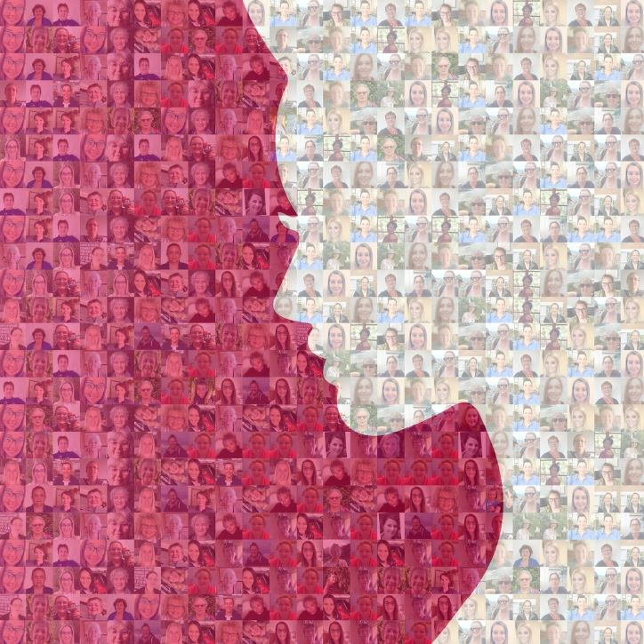

**Health Services**

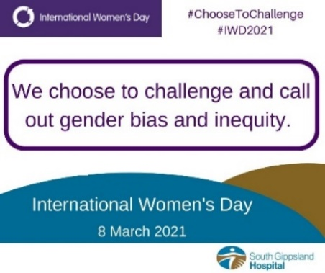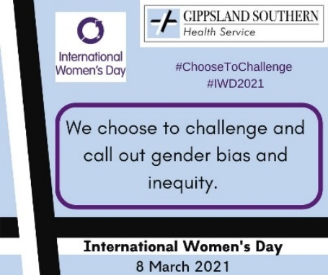Staff newsletter articles & Facebook Posts

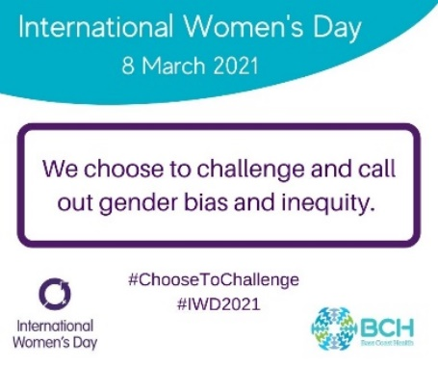**Community**

Bass Coast Community Foundation; music event at Archie’s Creek Hotel

Girls of our Town; an event at the Foster Museum honouring 65 local women of the Corner Inlet District

**16 Days of Activism**

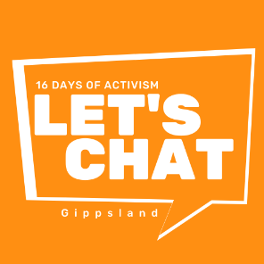*Let’s Chat Gippsland* has been this year’s local approach to the 16 Days of Activism campaign against Gender Based Violence, launched on the 25th of November and concluding on the 10th of December.

Led by Gippsland Women’s Health, the Partnership to Prevent Violence in South Gippsland and Bass Coast, collaborated on design and delivery of the Let’s Chat campaign. The central concept was ‘conversations to create change’ which aimed to support people to have important conversations about gender equality and respect in relationships.

The Partners participated in one or more of the 3 working groups,

* Film Campaign/Competition
* Social Media & Media using Gender Equality Messaging
* Visual Presence (flags, banners, stencils etc in the community

producing a diverse range of events and activities delivered across Gippsland, some in person and others online.

**South Gippsland Shire Council** displayed the Let's Chat logo to raise awareness of family violence prevention. The logo could be spotted at all town entries in South Gippsland as well as on banners at the Shire depot and on main office fences and buildings. The logo could also be spotted on selected Council vehicles and council staff could be seen be wearing Let's Chat facemasks to promote the campaign. To top it off, South Gippsland Shire Council colleagues and new Councillors did the [Walk Against Family Violence](https://www.facebook.com/southgippslandshirecouncil/posts/261913342629693?comment_id=262066892614338&notif_id=1637838915255710&notif_t=comment_mention&ref=notif) to raise awareness of family violence and its impact on the local community.

**Gippsland Centre Against Sexual Assault** (GCASA) promoted 16 Days in 16 Ways. A colourful calendar that provides simple daily activities that encourage active participation in the  16 Days of Activism. Once completed participants are encouraged to upload a picture onto the GCASA Instagram page with the hashtag #GCASA16DAYS16WAYS.

**Bass Coast Shire Council** staff joined together to Walk Against Violence on 25 November, from Wonthaggi Union Community Arts Centre to Wishart Reserve (in front of Council offices), and organised Let’s Chat Bass Coast, a space for their local partner organisations to come together for an inclusive and welcoming event to chat about the 16 Days of Activism on 10 December, to bookend the 16 Days. The event featured speakers from GCASA’s Sexual Lives & Respectful Relationships program and Gippsland Women’s Health and was well attended by both Council staff and community, including representatives from Bass Coast Health, Phillip Island Nature Parks and Interchange Gippsland. This event created a space for conversations by Council staff and the wider community to chat about gender equity

**Gippsland Women’s Health** hosted a Film Workshop-Respect in Relationships, supporting and encourage the community to take part in creating a short film about respect in relationships.

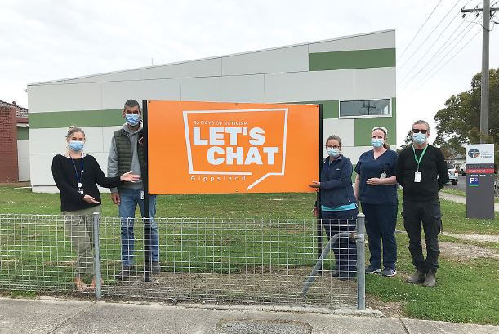Our local **health services**, Bass Coast Health, Gippsland Southern Health Service and South Gippsland Hospital all shared the Let’s Chat social media posts on their Facebook pages encouraging their communities to have important conversations about gender equality and respect in relationships. They also took the opportunity to promote their commitment to strengthening their ability to recognise and respond to family violence within the hospital walls.

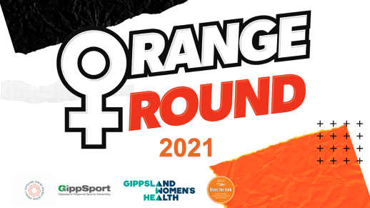**GippSport and GCASA** hosted a Summer Orange Round Information Session.They shared examples of how clubs can create safe, welcoming, and inclusive environments that promote gender equality.

Our **local schools** who implement the Respectful Relationships Initiative also participated in a variety of different ways. Many dressed up in orange, some had dedicated assemblies to bring attention to the issue of gender-based violence, others created orange information displays about respectful relationships and gender equality, some shared the Let’s Chat social media, while some Walked Against Family Violence.

