Choose Tap Campaign Toolkit

January 2022

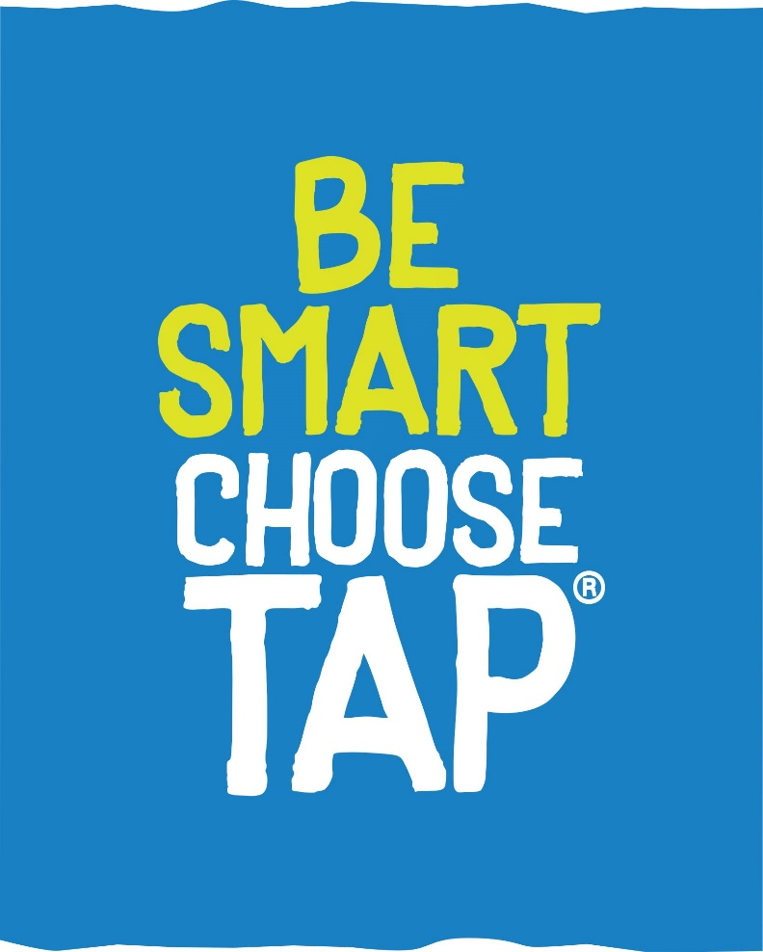

Sarah Green

Acting Prevention Manager

sarahg@southcoastpcp.org.au

0409 798 861

- Campaign Background
The South Coast Water Partnership is a formal partnership between Bass Coast Shire Council, South Gippsland Shire Council, South Coast Primary and Community Partnership (representing Bass Coast Health, Gippsland Southern Health Service and South Gippsland Hospital), GippSport, South Gippsland Water and Westernport Water.

The South Coast Water Partnership members have signed a joint statement of commitment to deliver collaborative initiatives that support the communities of Bass Coast & South Gippsland to increase their consumption of tap water utilising the national Choose Tap campaign.

- Key Messages

The Choose Tap campaign is a national initiative that promotes the health, environmental and financial benefits of drinking tap water.
- Our tap water is clean, safe and full of essential minerals to keep us performing at our best
- Grabbing a reusable bottle and refilling with tap water before we head out means less single use plastic waste ends up in our precious water ways.
- Not only is it better for nature and our health but it is also 2,000 times pricier when bought in a package.

- Campaign Resources
Within this kit you will find:
- Social Media Content
- Staff Newsletter Insert

Social Media Schedule
Social media posts have been developed for the Choose Tap campaign. Below is the content for posting on your organisation’s social media. A jpg of each image is attached to this email.

If you need any support please do not hesitate to contact us.
Date | Post Content | Image
Wednesday 5 January | Drinking tap water out of a refillable, reusable bottle has some big benefits! It is better for nature and better for us.  We are committed to making tap water the first drink of choice across Bass Coast and South Gippsland. And to affirm this we have signed a joint statement of commitment to the South Coast Water Partnership.  @Bass Coast Shire Council, @Gippsport, @South Coast PCP, @South Gippsland Shire Council, @South Gippsland Water & @Westernport Water have joined forces to encourage our community to @Choose Tap. Will you?  #BeSmartChooseTap  #ChooseTap | 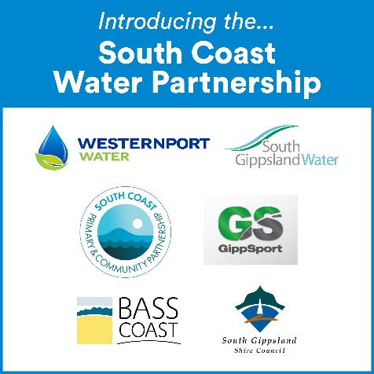
Wednesday 19 January | What are you waiting for?  Grab your reusable bottle and choose tap - the best choice you’re your health, your hip pocket, and the environment.  #BeSmartChooseTap  #ChooseTap
Wednesday 2 February | School’s Back!  Feel good hydration [insert smiling emoji]  Tap water is full of essential minerals, helping our kids to feel healthier and happier.  #BeSmartChooseTap  #ChooseTap
Wednesday 16 February | There is no time to waste.  Say no to single use plastic, and buy reusable products.  #BeSmartChooseTap  #ChooseTap
Wednesday 2 March | Heading out for a walk today?  Don't forget to bring along your reusable bottle to keep hydrated while on the go [insert running emoji]  #BeSmartChooseTap  #ChooseTap  #churchillisland
Wednesday 16 March | Dehydration is one of the leading causes of headaches.  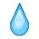  Keep yourself topped up with fresh tap water at work to keep performing at your best on the job [insert water drop emoji]  #BeSmartChooseTap  #ChooseTap | IMAGE TO FOLLOW
Tuesday 22 March | Happy World Water Day!  Brimming with essential nutrients and minerals, tap water will help you feel better with every refill.  #BeSmartChooseTap  #ChooseTap
Wednesday 30 March | Heading out for a walk with your pooch?  Don't forget to bring along your reusable bottle to fill up with fresh tap water on the go [insert water drop and dog emoji]  #BeSmartChooseTap  #ChooseTap

Staff Newsletter Insert
Be Smart Choose Tap
Drinking tap water out of a refillable, reusable bottle has some big benefits!

💧 Our tap water is clean, safe and full of essential minerals that keep us performing at our best.
💧 Not only is it great for our health it’s a step towards cleaner, greener waterways, free from single use plastic.
💧 The water in our taps is the most precious resource we have and it’s also over 2,000 times pricier when bought in a package.

Choose Tap and see the benefits for your health, the environment and your hip pocket.

