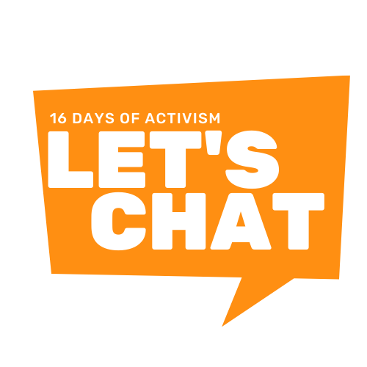
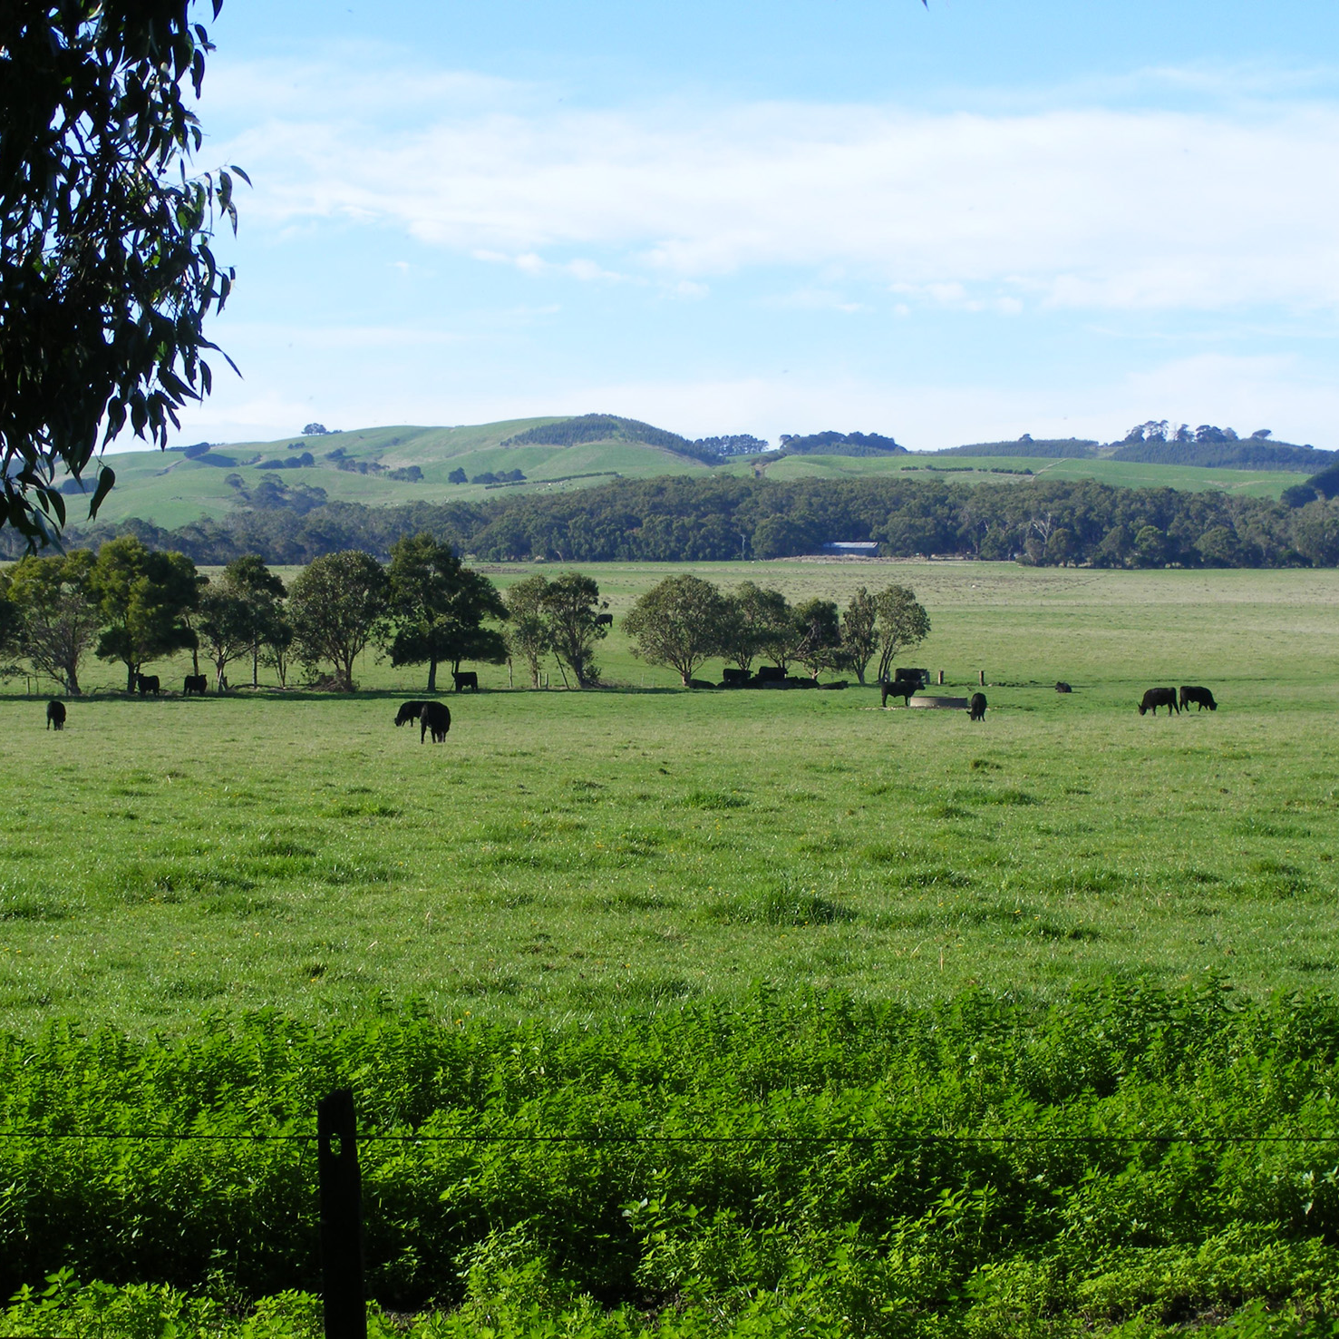

16 Days of Activism against Gender-Based Violence Campaign Toolkit

25 November - 10 December 2021

- Campaign Background

The 16 Days of Activism against Gender-Based Violence originated from a petition that was circulated during the 1991 United Nations World Conference on Human Rights. The petition called on the conference committee to address women’s human rights and recognise gender-based violence as a human rights issue. The 16 Days of Activism against Gender-Based Violence begins on the International Day for the Elimination of Violence Against Women (25 November) and ends on International Human Rights Day (10 December) and is now a widely recognised global campaign.

Communities across Gippsland have been working together on activities in line with one clear message; Let’s Chat about putting an end to violence against women, led by Gippsland Women’s Health. The campaign’s central concept is ‘conversations to create change’ and aims to support people to have important conversations about gender equality and respect in relationships.

Key Messages

In Australia, on average, 1 woman is murdered by a current or former partner each week, and 1 in 2 women has experienced sexual harassment. Gender inequality is the core of the problem; thus, gender equality is the heart of the solution. It is everyone’s responsibility to be an active part of addressing gender inequality in Australia, because women and girls deserve to be treated as equals.

Campaign Resources
Within this kit you will find:
- Social media content
- Staff newsletter insert – with zoom background and email signature to download

- Social media content
Social media posts have been developed for the 16 Days of Activism against Gender-Based Violence. Below is a table of the content and images for posting on your organisation social media.

High resolution versions of the images are attached to this email. These can be scheduled on your social media platform, so you can simply set and forget.

If you need any support please do not hesitate to contact us.

Date | Post Content | Sample image (use PNG attached to this email for posting)
Thursday  25 Nov | Over the next 16 days, Gippslanders will be chatting about what we can do to make our community a place where everyone is safe, respected and treated as equals.  Sometimes we are not sure what we can do.  But we know that having conversations can be a good first step.  Let's Chat with those around us about putting an end to gender-based violence.  To find out more visit www.16daysgippsland.com.au  If you need help;  In an emergency call 000.  Safe Steps on 1800 015 188.  Gippsland Centre Against Sexual Assault on 1800 806 292.  #16DaysOfActivism #RespectIs #LetsChatGippsland | 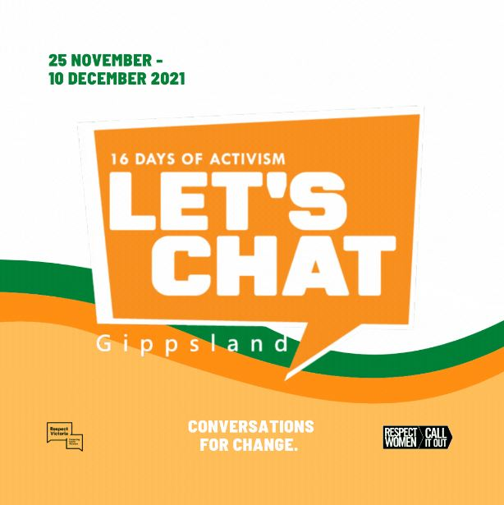
Friday  26 Nov | All Gippslanders deserve to be free to be who they are, without expectations based on their gender.  Society can make us feel like we need to follow stereotypes. It tells us that we should have certain likes, dislikes, interests and abilities based on our gender.  But we know that everyone is much more than a stereotype.  Let’s Chat with those around us about supporting one another to develop our own identities that are not limited by gender stereotypes.  Learn more: https://bit.ly/gender-roles-stereotypes  If you need help;  In an emergency call 000.  Safe Steps on 1800 015 188.  Gippsland Centre Against Sexual Assault on 1800 806 292.  #16DaysOfActivism #RespectIs #LetsChatGippsland www.16daysgippsland.com.au | 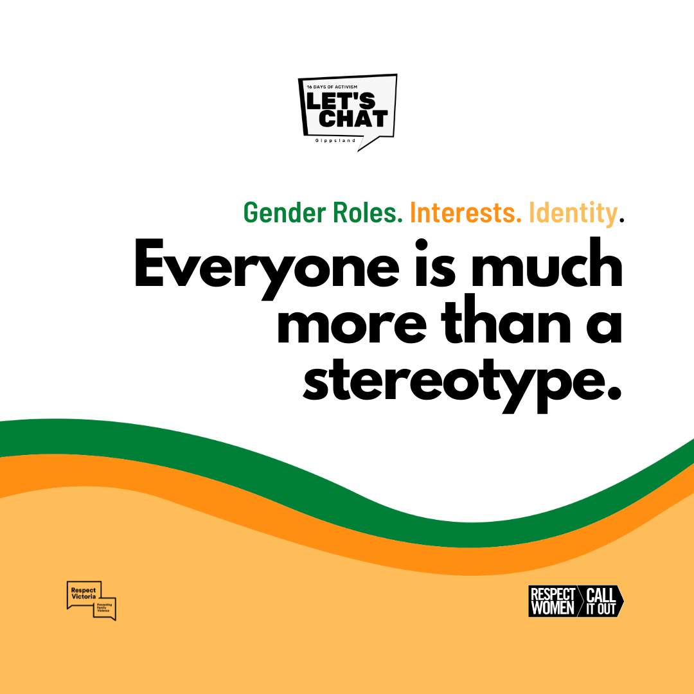
Saturday  27 Nov | We all want to feel respected as equals in our relationships.  While a lot of things have changed over the decades, there is still more pressure on women to care for children and clean the home, even if they work full time. These outdated expectations lock men and women into unequal roles that don’t help any of us live the life we really want.  Let's Chat with those around us about challenging outdated expectations and modelling equal relationships for our children to follow.  Learn more: https://bit.ly/fairness-at-home  If you need help;  In an emergency call 000.  Safe Steps on 1800 015 188.  Gippsland Centre Against Sexual Assault on 1800 806 292.  #16DaysOfActivism #RespectIs #LetsChatGippsland www.16daysgippsland.com.au | 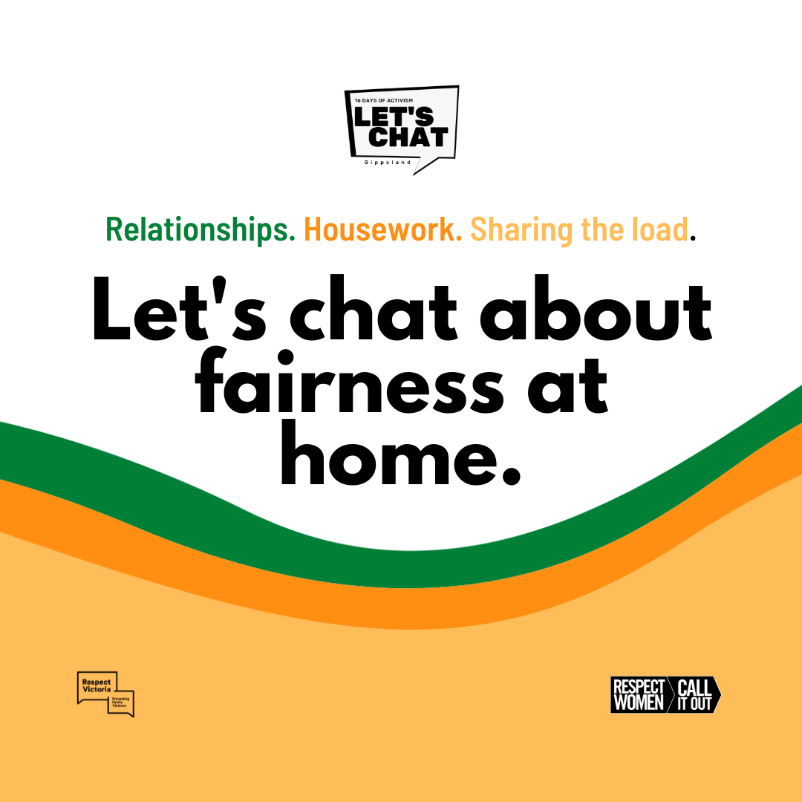
Sunday  28 Nov | The culture, lives and voices of Aboriginal and Torres Strait women deserve to be celebrated, heard and respected.  Yet, Aboriginal and Torres Strait Islander women are the most legally disadvantaged group in Australia. Intergenerational trauma, discrimination and a lack of support mean they are more likely to experience family violence.  Let's Chat with those around us about recognising Aboriginal and Torres Strait Islander women's cultural strength.  Learn more: https://bit.ly/djirra-prevention  If you need help;  In an emergency call 000.  Safe Steps on 1800 015 188.  Gippsland Centre Against Sexual Assault on 1800 806 292.  #16DaysOfActivism #RespectIs #LetsChatGippsland www.16daysgippsland.com.au | 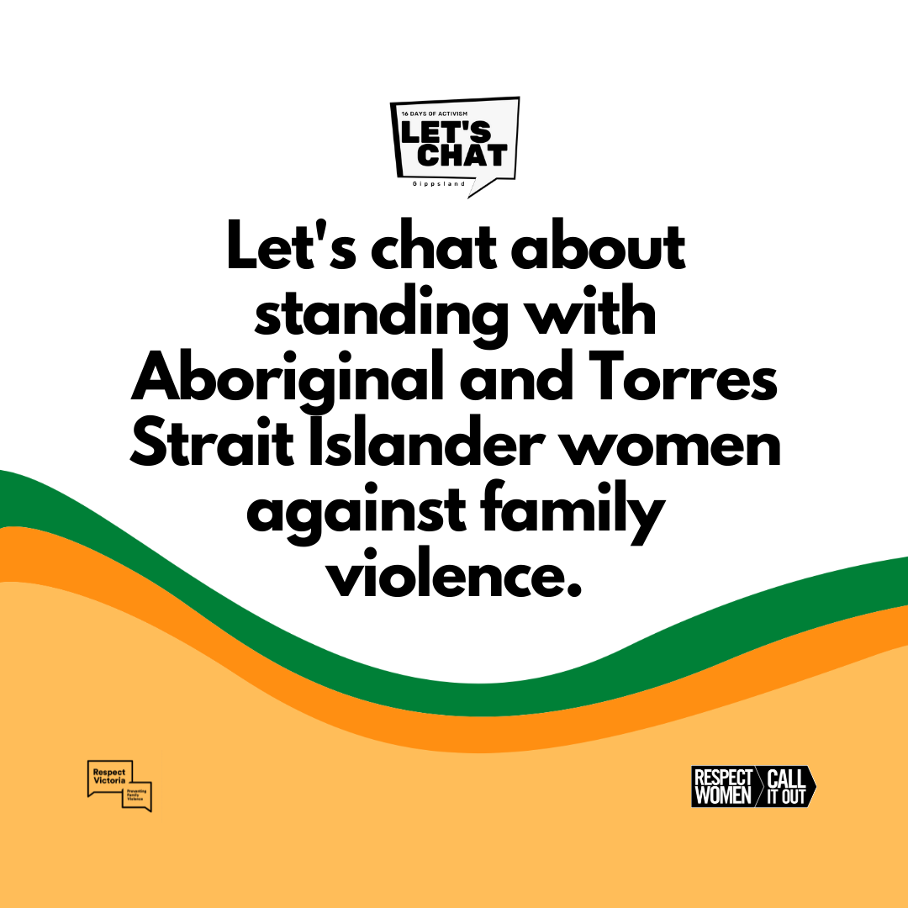
Monday  29 Nov | Children deserve to be free to be who they are, not who society says they should be.  Messages received from family, friends and advertising can lead children to certain beliefs, behaviours and life choices. Our words are powerful. The belief that boys should be ‘tough’ can lead boys to think it’s not right to show their emotions or be caring.  Boys raised free from outdated masculine stereotypes are more likely to enjoy healthy, respectful relationships.  Let's Chat with those around us about freeing our boys from outdated masculine stereotypes.  Check out this 2-part podcast series "Let's Chat about; supporting healthier masculinities in children" available to stream here: https://bit.ly/LetsChatPodcast  Learn more: https://bit.ly/trapped-in-man-box  If you need help;  In an emergency call 000.  Safe Steps on 1800 015 188.  Gippsland Centre Against Sexual Assault on 1800 806 292.  #16DaysOfActivism #RespectIs #LetsChatGippsland www.16daysgippsland.com.au | 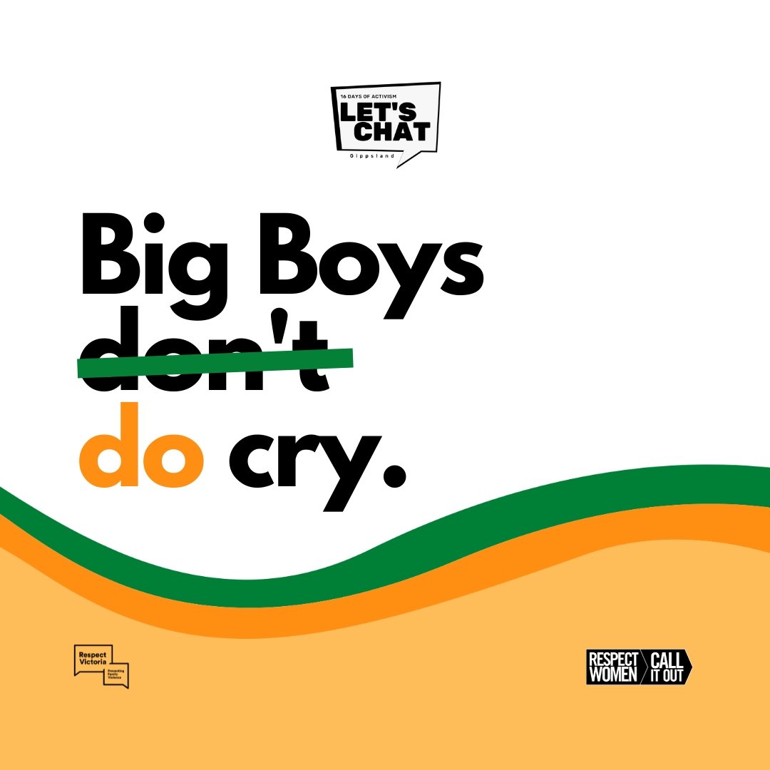
Tuesday  30 Nov | Everyone should feel welcomed and respected in community sport.  Many sporting clubs are already doing a lot of great work in creating more inclusive spaces for women and girls.  By using inclusive, neutral language and creating opportunities for women and girls – we can make sure our clubs are fair for all.  Let's chat with those around us about equality in our sports clubs.  @GippSport offer free support for clubs to be fair and equal, helping to end violence against women.  Get your club involved: https://bit.ly/Orange-Round  If you need help;  In an emergency call 000.  Safe Steps on 1800 015 188.  Gippsland Centre Against Sexual Assault on 1800 806 292.  #16DaysOfActivism #RespectIs #LetsChatGippsland www.16daysgippsland.com.au | 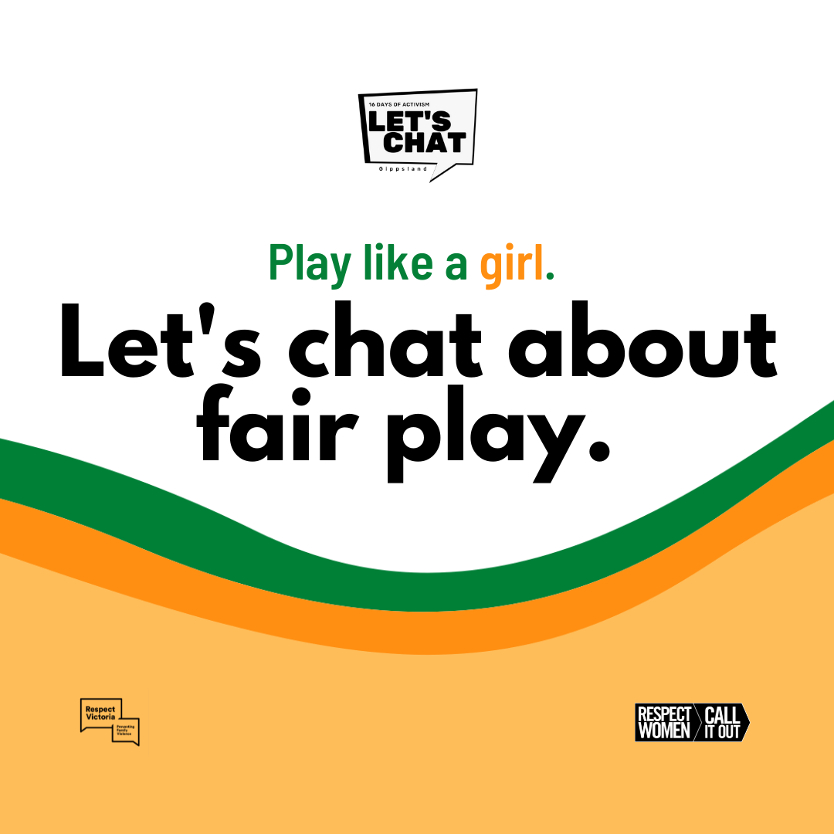
Wednesday  1 Dec | All of us want relationships and families filled with love and respect.  However, homophobic, biphobic and transphobic legislation, systems and attitudes mean it’s less likely that LGBTQIA+ couples, parents and young people will seek help when someone uses violence against them.  We know that recognising and celebrating LGBTQIA+ communities, relationships and families makes a difference.  Let's Chat with those around us about creating a safer community where people from LGBTQIA+ communities can freely ask for help.  Learn more: https://bit.ly/sc-inclusion  https://bit.ly/dvrcv-lgbtqia  If you need help;  In an emergency call 000.  Safe Steps on 1800 015 188.  Gippsland Centre Against Sexual Assault on 1800 806 292.  #16DaysOfActivism #RespectIs #LetsChatGippsland www.16daysgippsland.com.au | 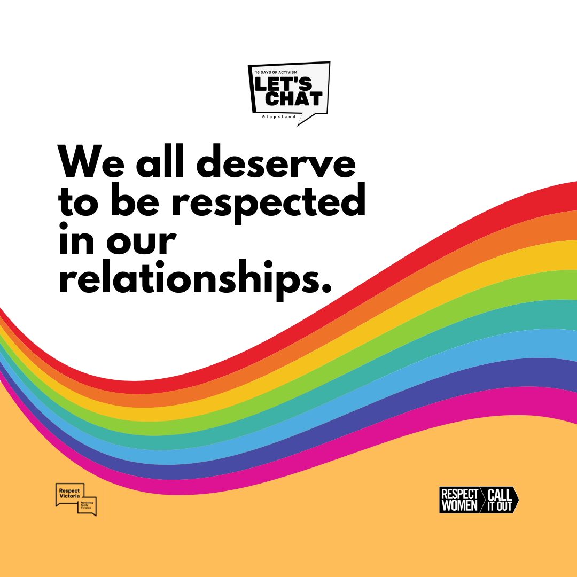
Thursday  2 Dec | Female farmers deserve to be respected as individuals with their own skills and aspirations.  Many women in agriculture find their opportunities in life and business are limited by outdated assumptions and are treated differently because of their gender.  Let's Chat with those around us about empowering women and valuing them as significant contributors to the agricultural industry.  Learn more: https://bit.ly/not-the-farmers-wife  If you need help;  In an emergency call 000.  Safe Steps on 1800 015 188.  Gippsland Centre Against Sexual Assault on 1800 806 292.  #16DaysOfActivism #RespectIs #LetsChatGippsland www.16daysgippsland.com.au | 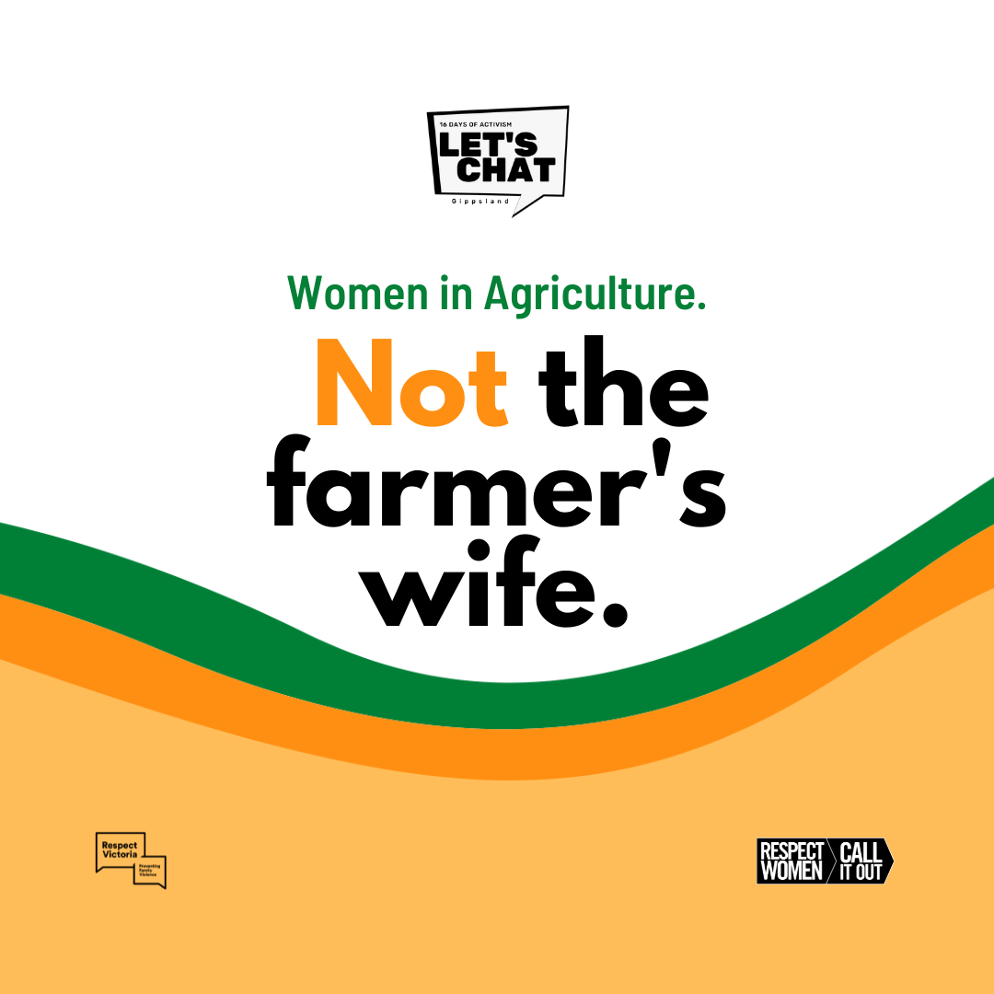
Friday  3 Dec | Happy International Day of People with a Disability.  Women and girls with disabilities deserve to participate in all aspects of life.  However, an alarming portion of women are being denied that basic right. Being discriminated by gender and disability increases the likelihood of violence towards women with disabilities.  Let's Chat with those around us about listening to the experiences of women with a disability.  Our communities are stronger when we recognise diversity.  Learn more: https://bit.ly/women-with-disabilities  If you need help;  In an emergency call 000.  Safe Steps on 1800 015 188.  Gippsland Centre Against Sexual Assault on 1800 806 292.  #16DaysOfActivism #RespectIs #LetsChatGippsland www.16daysgippsland.com.au | 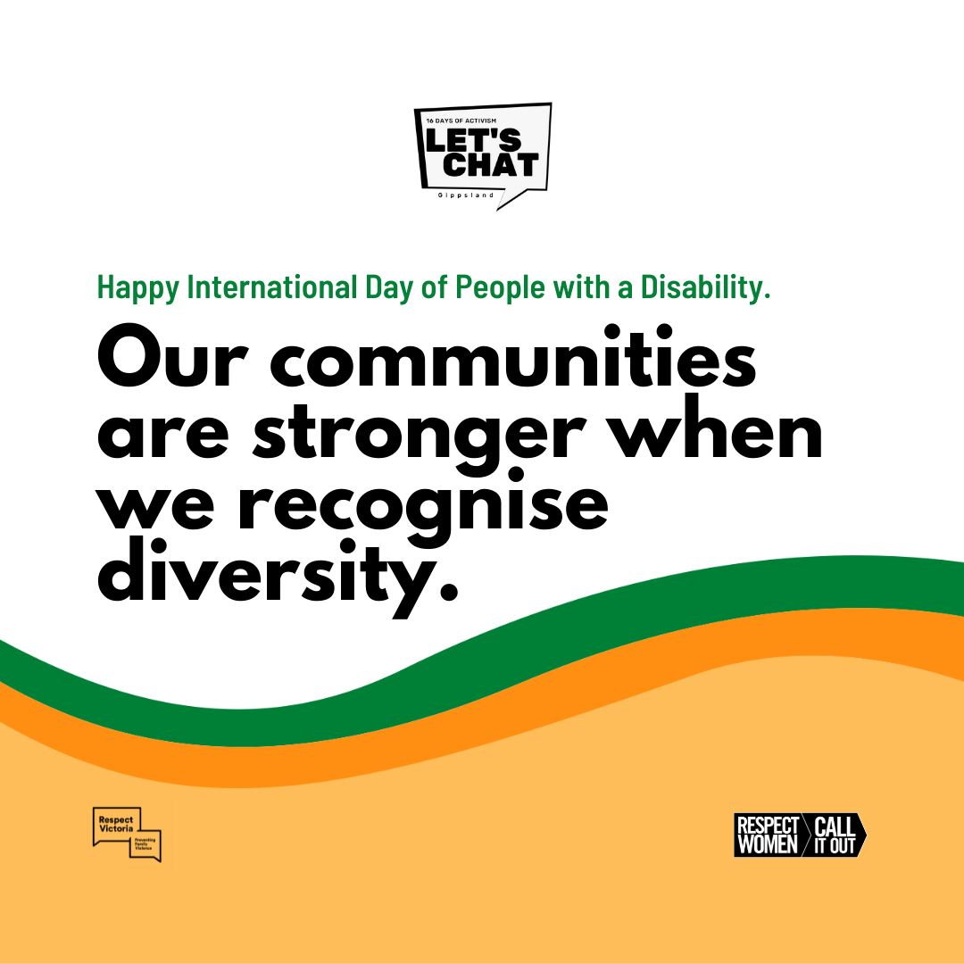
Saturday  4 Dec | Being active not only works wonders on our long-term physical health, it's also important for our mental wellbeing.  Yet too often, the environments in which women are active are not welcoming or supportive, leading to fear of judgement from others, often stopping women from participating.  Let’s Chat with those around us about creating welcoming and supportive environments that empower women to enjoy being active without worrying about judgement, their appearance, gender stereotypes or skills.  Learn more: https://bit.ly/gippy-girls-can  If you need help;  In an emergency call 000.  Safe Steps on 1800 015 188.  Gippsland Centre Against Sexual Assault on 1800 806 292.  #16DaysOfActivism #RespectIs #LetsChatGippsland www.16daysgippsland.com.au | 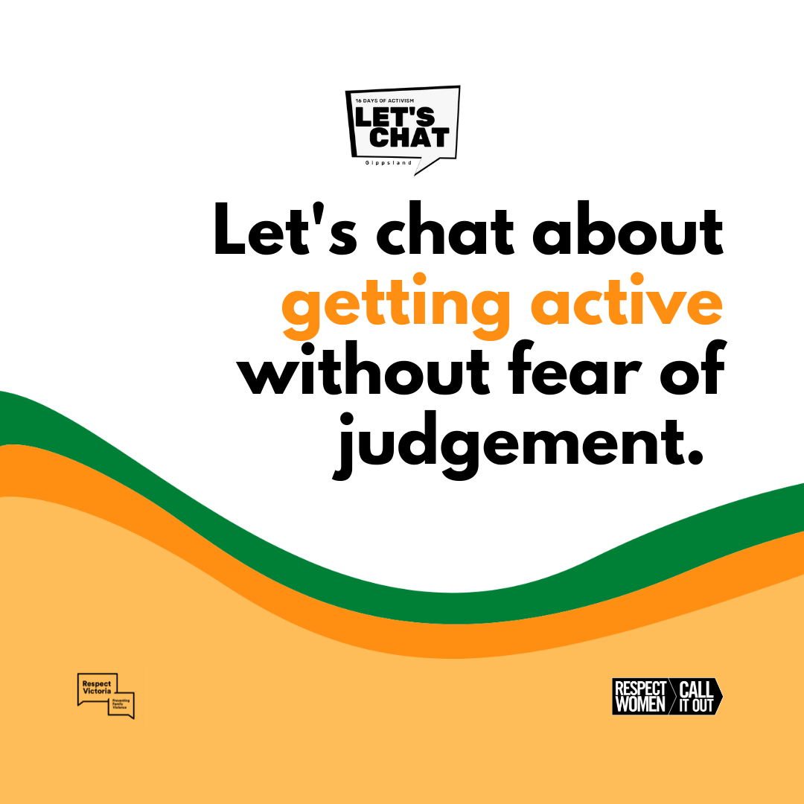
Sunday  5 Dec | Children deserve to be who they want to be.  The reality is, too many of us expect different things from boys and girls, and we often treat them differently, without even realising it.  Let's Chat with those around us about raising children as equals and freeing them from outdated stereotypes. Even the little things count - from the toys they play with, letting them express their emotions and opening their minds to what they can be when they grow up.  Learn more: https://bit.ly/level-playground  If you need help;  In an emergency call 000.  Safe Steps on 1800 015 188.  Gippsland Centre Against Sexual Assault on 1800 806 292.  #16DaysOfActivism #RespectIs #LetsChatGippsland www.16daysgippsland.com.au | 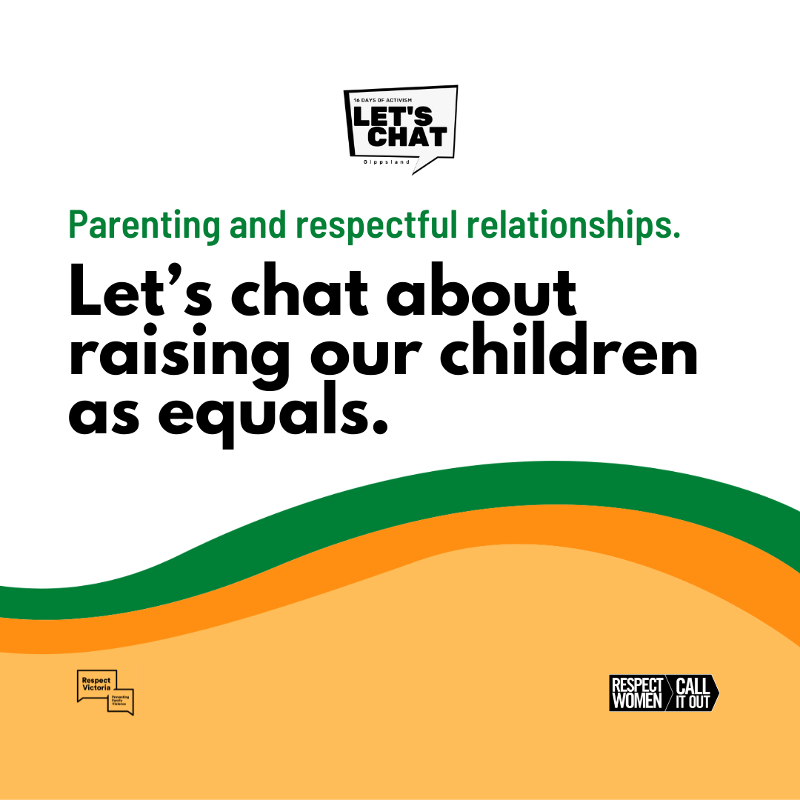
Monday  6 Dec | What we value in people should be the same, whether you are a man or a woman. After all, being a good "woman" or "man" is simply about being a good person.  There’s still a lot of pressure on men to live up to being tough, hiding parts of themselves. Not only do these outdated ideas of manhood lead to high rates of depression and suicide in men, they also contribute to violence against women.  Let’s Chat with those around us about role modelling being a good person so that boys and young men live happy and fulfilled lives.  Learn more: check out the 2-part podcast series "Let's Chat about...supporting healthier masculinities in children" available to stream here: https://bit.ly/LetsChatPodcast  If you need help;  In an emergency call 000.  Safe Steps on 1800 015 188.  Gippsland Centre Against Sexual Assault on 1800 806 292.  #16DaysOfActivism #RespectIs #LetsChatGippsland www.16daysgippsland.com.au | 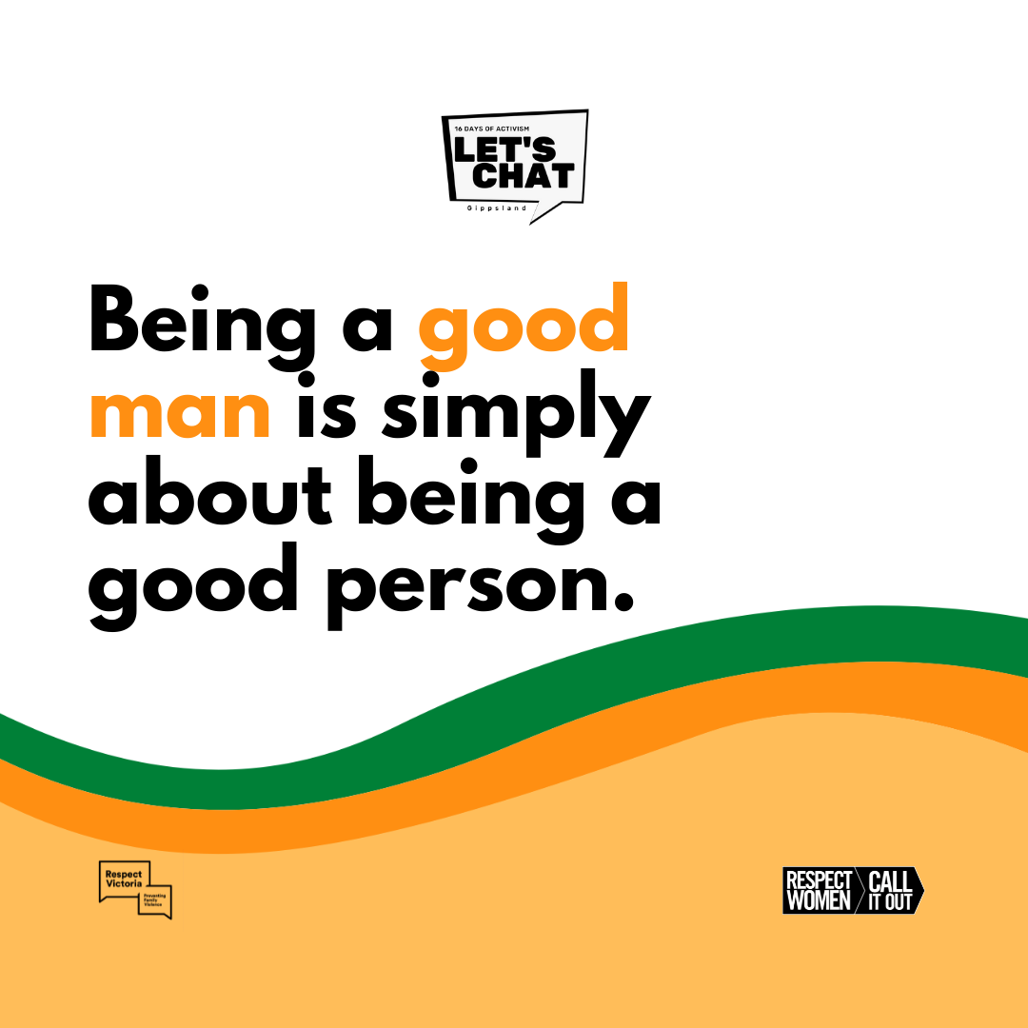
Tuesday  7 Dec | There is a place in sport for everyone, exactly as they are.  Sometimes the language we use can make it clear to young people in LGBTQIA+ communities that they’re not welcome. At its worst, this can lead to violence – which doesn’t belong in the game, or anywhere else.  Let’s Chat to those around us about the words we use and making a place in sport for everyone.  Learn more: https://bit.ly/lgbtqia-sport  If you need help;  In an emergency call 000.  Safe Steps on 1800 015 188.  Gippsland Centre Against Sexual Assault on 1800 806 292.  #16DaysOfActivism #RespectIs #LetsChatGippsland www.16daysgippsland.com.au | 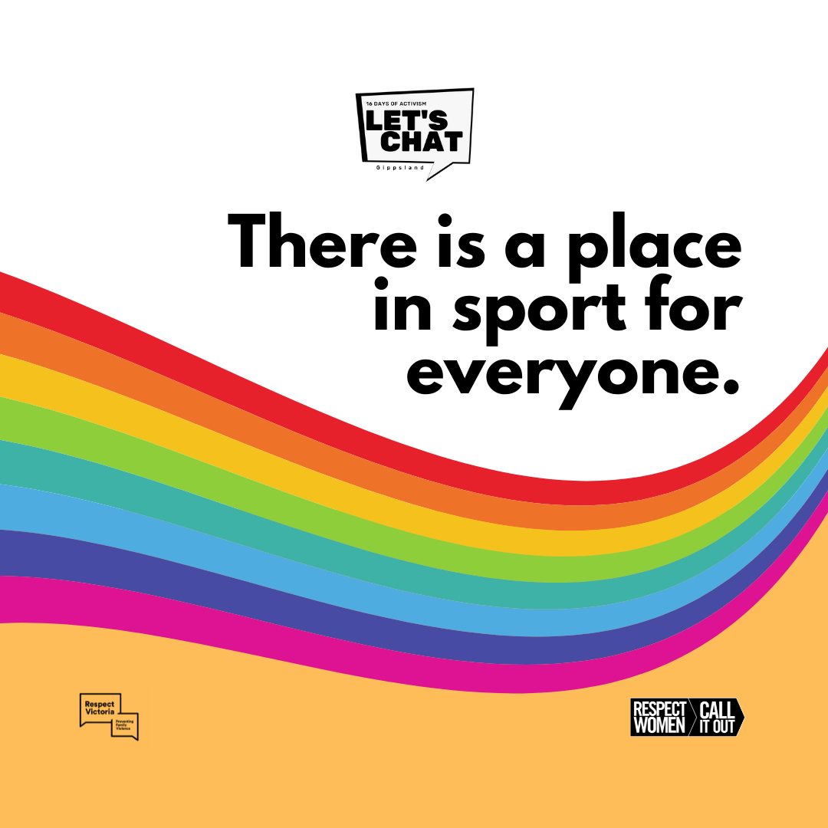
Wednesday  8 Dec | People from all cultures deserve to live in a community where they feel included, respected and are treated as equals.  However, migrant and refugee women often experience both sexism and racism. They may be afraid to seek support, when living with violence, due to fear of losing their right to live in Australia.  Let's Chat to those around us about listening to and believing the experiences of migrant and refugee women.  Learn more: https://bit.ly/migrant-refugee  If you need help;  In an emergency call 000.  Safe Steps on 1800 015 188.  Gippsland Centre Against Sexual Assault on 1800 806 292.  #16DaysOfActivism #RespectIs #LetsChatGippsland www.16daysgippsland.com.au | 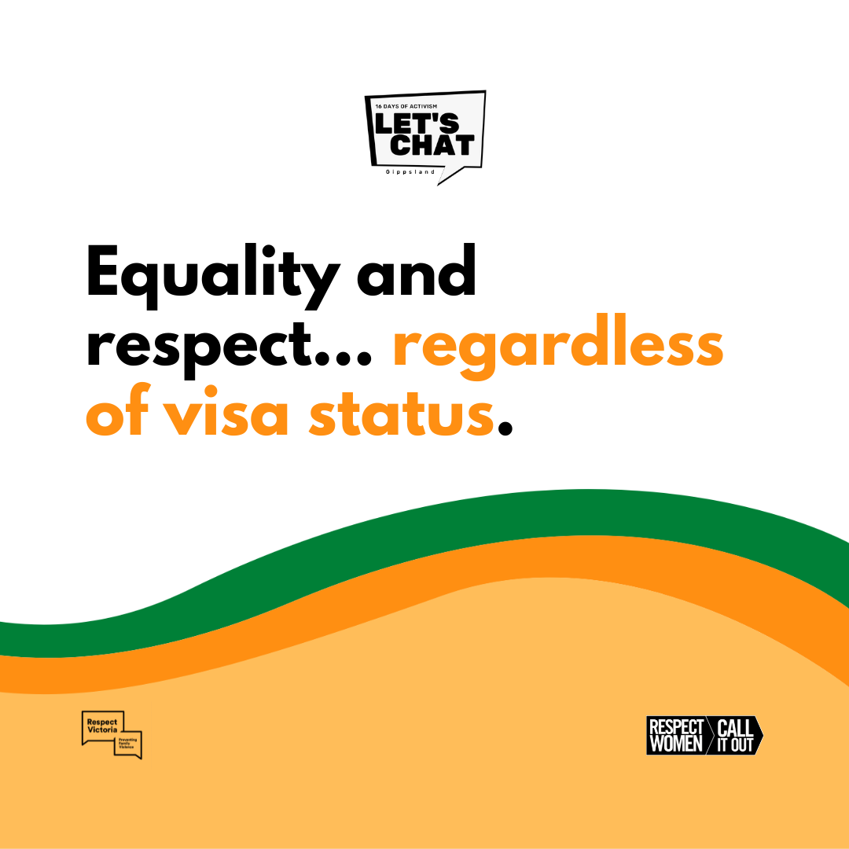
Thursday  9 Dec | We all deserve to be recognised and respected in the workplace as individuals with our own interests, skills and aspirations.  Many people find their opportunities are shaped by outdated assumptions related to gender and are treated differently in the workplace. Women can face additional barriers, where employers overlook them for senior roles. As a result, men are over-represented in leadership roles.  Let's Chat with those around us about the Gender Equality Act in Gippsland workplaces.  Learn more: https://bit.ly/gender-equality-act  If you need help;  In an emergency call 000.  Safe Steps on 1800 015 188.  Gippsland Centre Against Sexual Assault on 1800 806 292.  #16DaysOfActivism #RespectIs #LetsChatGippsland www.16daysgippsland.com.au | 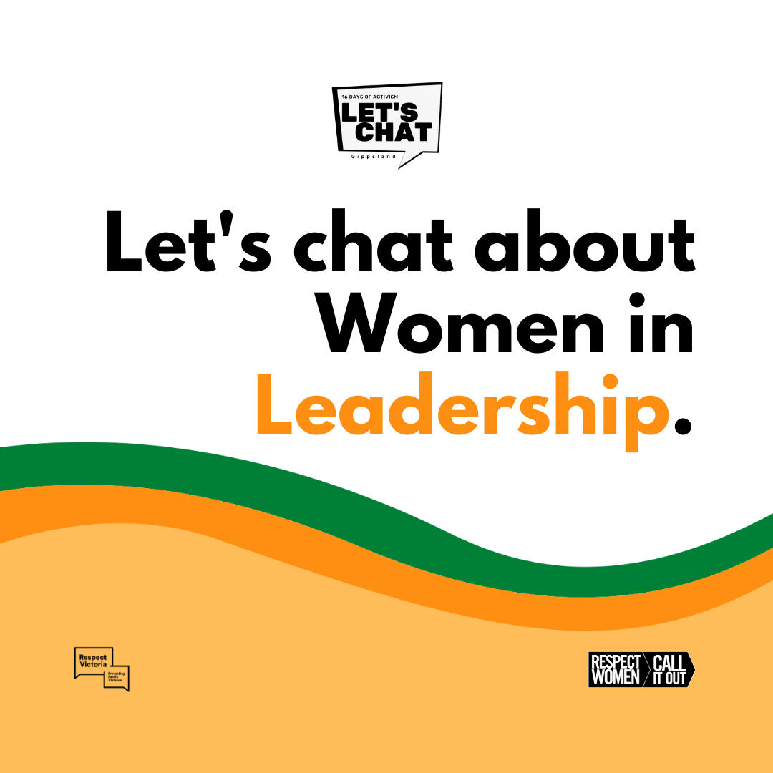
Friday  10 Dec | Today is Human Rights Day and marks the last day of the Let's Chat Gippsland campaign.  We hope you've had some great conversations about gender equality and respect in relationships.  The future is gender equality — it’s up to all of us to make it happen!  Let's continue to Chat: https://bit.ly/the-conversation-guide  If you need help;  In an emergency call 000.  Safe Steps on 1800 015 188.  Gippsland Centre Against Sexual Assault on 1800 806 292.  #16DaysOfActivism #RespectIs #LetsChatGippsland www.16daysgippsland.com.au | 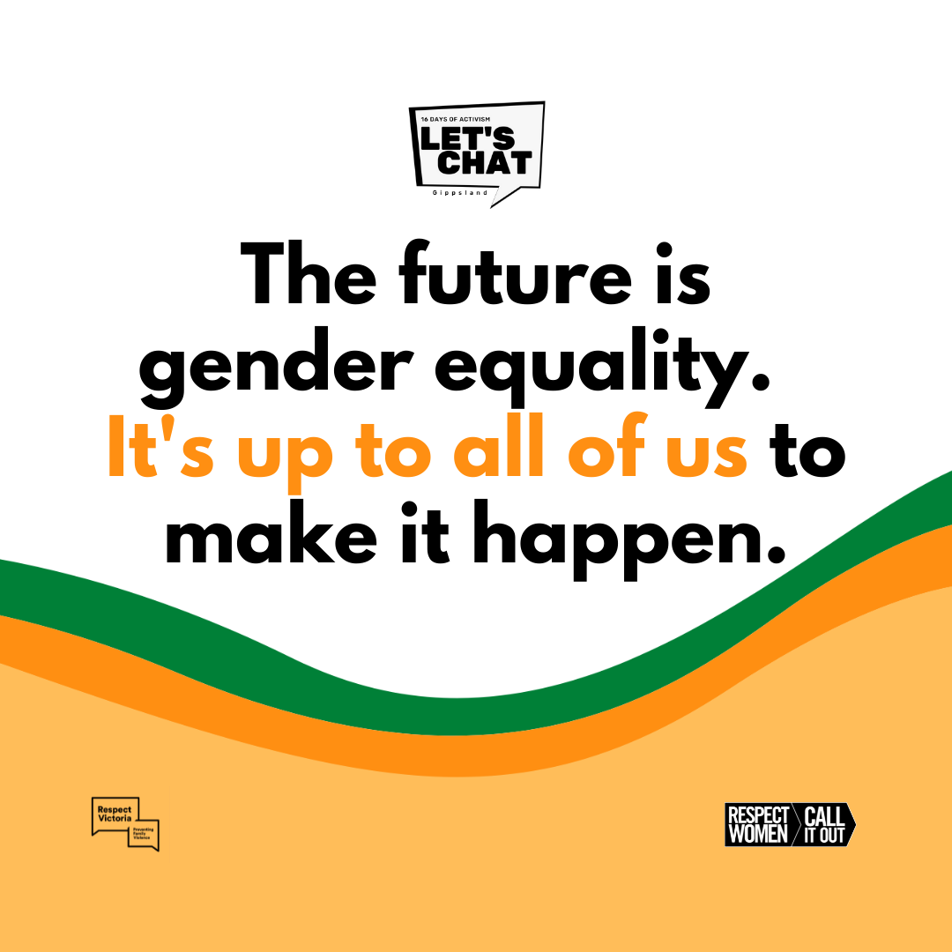

- Staff Newsletter Insert
Let’s Chat; conversations can create change.
All women and girls deserve to be respected, valued and treated as equals.

Let’s Chat Gippsland is this year’s regional campaign for the 16 Days of Activism against Gender-Based Violence (25 November – 10 December). It aims to encourage and support people to have important conversations with those around them about gender equality and respect in relationships.

Show your support during the 16 Days of Activism against Gender-Based Violence;
- Start a conversation with those around you about gender equality and respect in relationships. We will be posting Let’s Chat Gippsland campaign materials on our Facebook page to help stimulate respectful conversations
- Wear a splash of orange
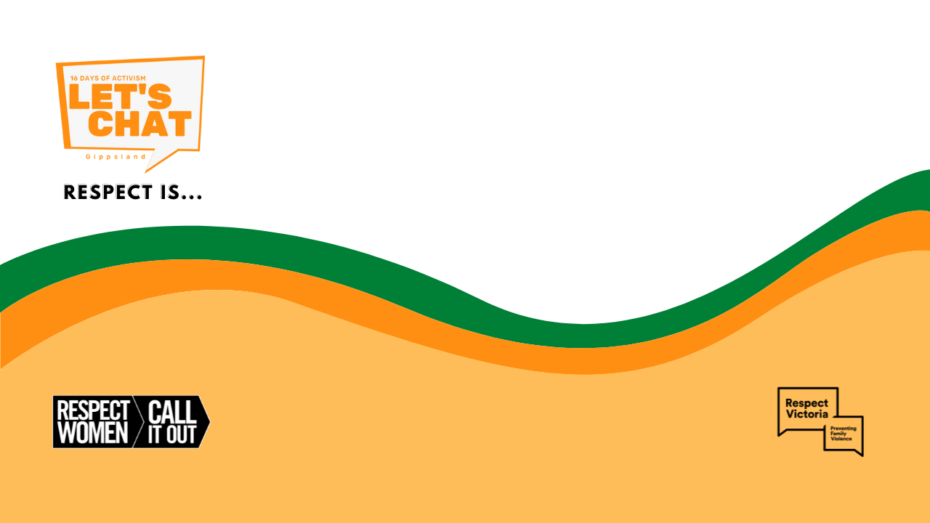
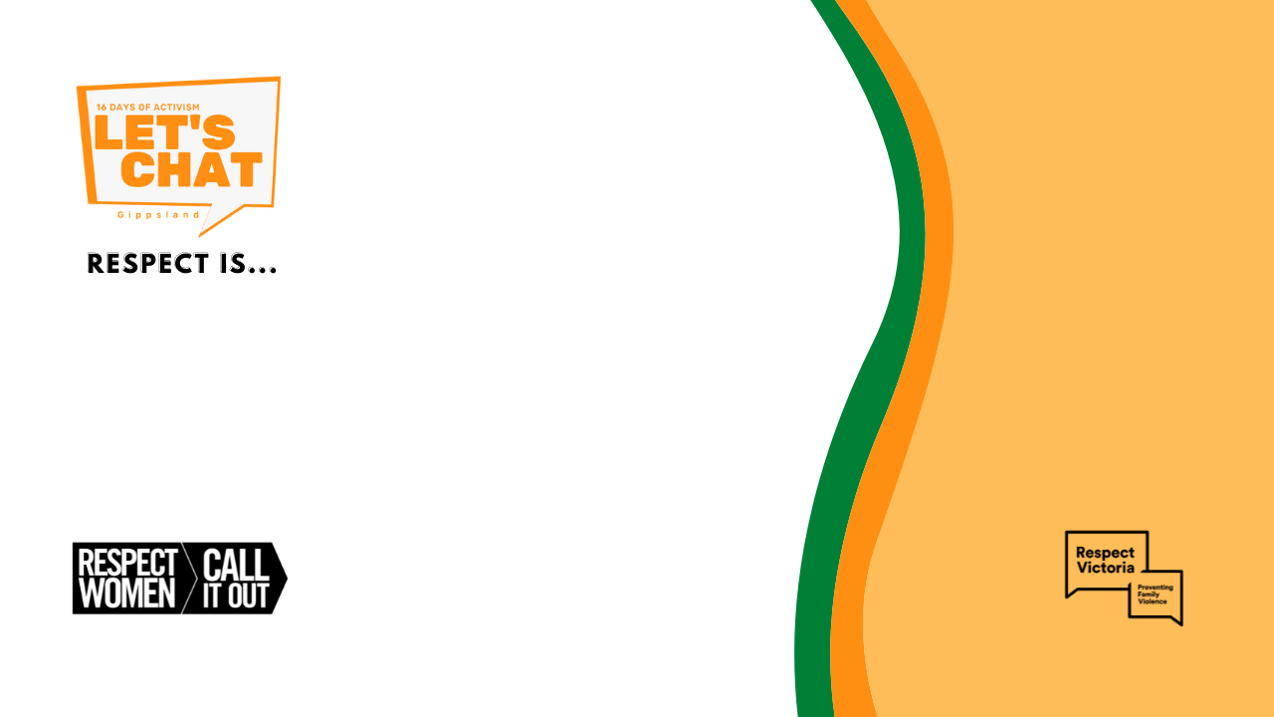
- Click on these zoom backgrounds to download and use in your meetings

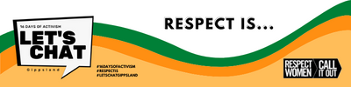
- Click on this graphic to download and add to your email signature

We all have a responsibility in strengthening our hospitals response to family violence. MARAM training is available to assist you to recognise the signs of family violence and how to respond to ensure all women and children are safe. Learn more about MARAM here.
If you need support, please speak to your manager and make the most of our Employee Assistance Program; 1300 687 327. Our family violence workplace support policy also provides support options, including de-identified family violence leave.

If you are in a violent or unsafe situation or know someone who is experiencing violence please refer to the specialist agencies listed below. Always call 000 in an emergency.
- The Orange Door-Inner Gippsland 1800 319 354
- Safe Steps 1800 015 188
- 1800 737 732 Gippsland Centre Against Sexual Assault
- 1800 Respect (National Sexual Assault, Family Violence Counselling)
The Community Guide to Family Violence Services in Bass Coast and South Gippsland also lists where to get help locally.

